REQUIREMENTS :

Blur Navigation Bar Like DTC

<https://www.dubaitaxi.ae/en>

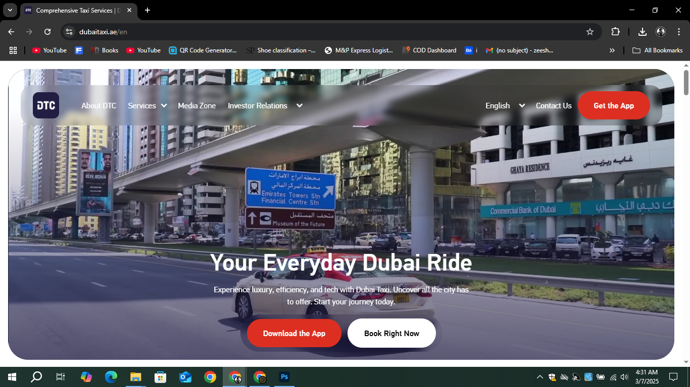

Add Services Like MB Car Lift

<https://dubaitoabudhabicarlift.com/>

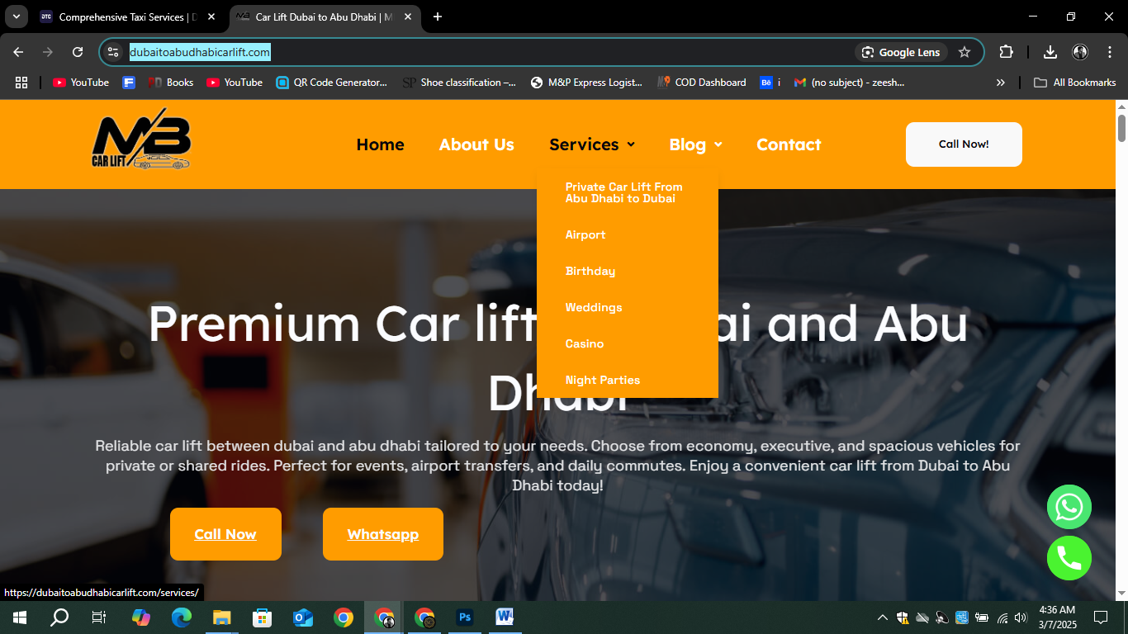

SECTIONS

1. Home
2. Services (Private Car Ride, Shared Car Ride, Parties, Casinos   
   Airports)
3. Book Ride
4. Contact
5. About Us

Add Call Now Button   
Whatsapp Number   
+971 50 710 6162

Add Social Medias